# **Patient Tracker System**

**Midpoint Deliverable**

**Riya Deshpande Riya Danve Riya Adsul Mitali Juvekar**

*GitHub Repository Link:* [*https://github.com/riyaa74/PatientTrackerSystem*](https://github.com/riyaa74/PatientTrackerSystem)

## 1. Requirements

## 1.1. Overview

## 1.2. Features

-

## 1.3. Functional Requirements (Use cases)

## 1.4. Non-Functional Requirements

# 2. Design

## 2.1. Architecture Diagram

The language used for the implementation is Python. The high-level architecture diagram of the proposed patient tracker system is as below.

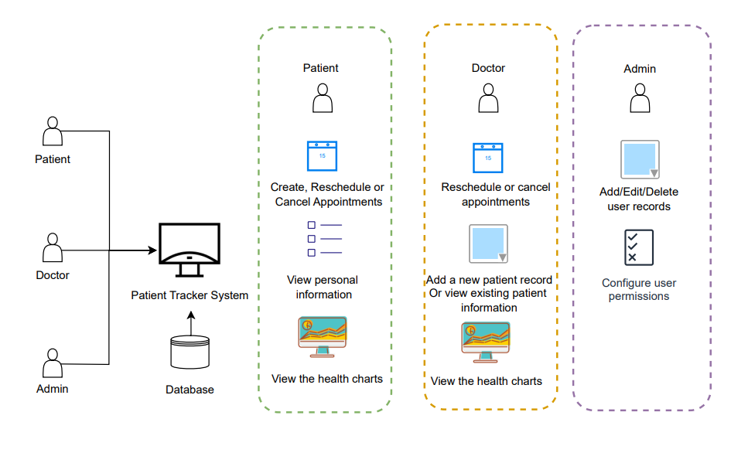

Figure 1: Patient Tracker System Architecture Diagram

## 2.2. Technology Stack with Justification

- Guideline: List out the technologies used in the project and provide reasoning for the choice. Discuss the advantages of chosen technologies in relation to the project's requirements.

- Example: "We chose Flask for backend development due to its lightweight nature and flexibility in developing web applications."

## 2.3. UI Mockup

- Guideline: Provide visual representations or wireframes of the user interface. This helps in giving a tangible sense of how the user would interact with the product.

- Example: Screenshots or sketches of the main pages/screens of the application. Showcase a few user interface designs and layouts for the system, emphasizing doctor and patient interactions.

## 2.4. Data Model:

The following diagram below illustrates the data model of the project by showing the entities, their attributes and their interdependence.

Figure 1: Data Model of the proposed Patient Tracker System

# 3. Implementation

Outline the coding process, methodologies to be followed, and potential challenges.

## 3.1. Security and Risks

-Data Breach

* Description of the potential threats and vulnerabilities.
* Measures taken to prevent unauthorized data access.
* HIPAA Compliance (in case of Patient Tracker)
* Explanation of the Health Insurance Portability and Accountability Act (HIPAA) and its relevance to the project.
* Steps and protocols followed to ensure the system's compliance with HIPAA.

## 3. Work Plan

- Guideline: This is where you detail the steps to be taken to execute the project. Think of it as a roadmap or high-level timeline. You also specify each group member’s responsibility and planned contribution to the project development.

- Example:

Group Member 1: List of tasks to be done

Group Member 2: List of tasks to be done

Group Member 3: List of tasks to be done

High-level Timeline: This can include the incremental development plan. You can follow the Spring development plan presented in Moodle too.